# AI Assignment 2 :

1. Program Screenshot on both the dfs and best first algorithm .

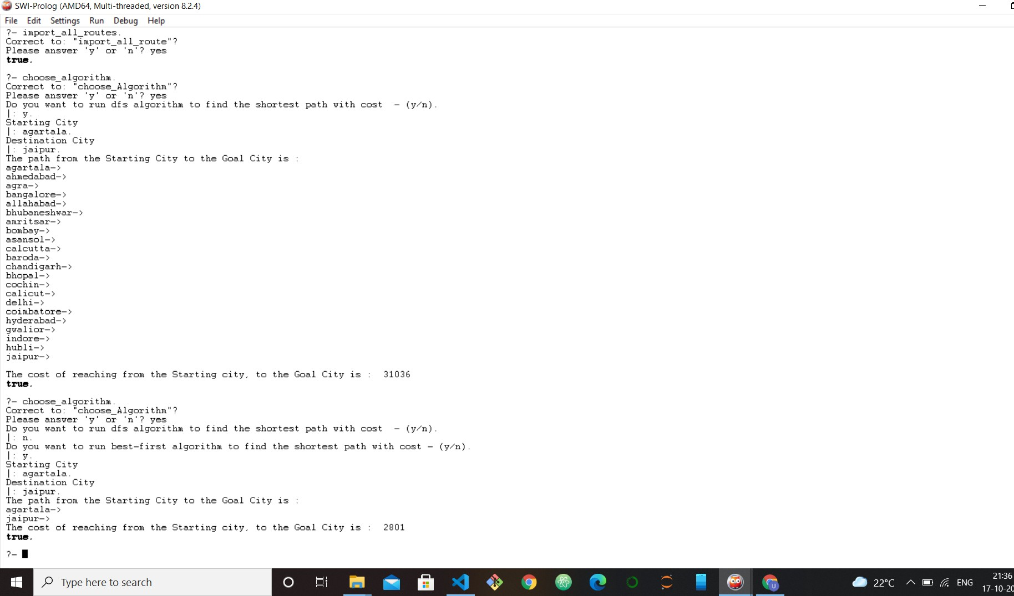Screenshot from the prolog program :

1. Prolog Program Code :

/*For running the program you have to import the csv file called by road_distance.csv

By calling this way:

import_all_routes.

And then just run the program by typing choose_algorithm. */

/*

importing the file distance_route.csv in order to make the facts of distance between 2 cities */

import_all_route :-

csv_read_file('road_distance.csv' ,R, [functor(give_Distance), arity(3)]),

maplist(assert, R).

% User choose the Dfs algorithm to proceed further. choose_Algorithm :-

write("Do you want to run dfs algorithm to find the shortest path with cost - (y/n)."),

nl, read(Ans), Ans=y,

!, % cut is used here so cannot backtrack from here write("Starting City"),nl,

read(Start_city), write("Destination City"),nl, read(End_city),

solve_With_Dfs(Start_city, End_city).

% Best first search initialization. choose_Algorithm :-

write("Do you want to run best-first algorithm to find the shortest path with cost - (y/n)."),

nl, read(Ans), Ans=y,

!, % cut is used here so cannot backtrack from here write("Starting City"),nl,

read(Start_city), write("Destination City"),nl, read(End_city),

solve_With_BestFirst(Start_city, End_city).

% solving with the depth first search algorithm

solve_With_Dfs(Start_city,End_city) :-

write("The path from the Starting City to the Goal City is :

"), nl,

depthfirstSearch([], Start_city, End_city,Solution), reverse(Solution,Path),

print_Path_dfs(Path),nl,

write("The cost of reaching from the Starting city, to the

Goal City is : "),

find_Cost(Path,Best_cost), write(Best_cost), nl ,!.

% writing the logic for depth first search

% when the Start_city mathces with the End_city.

depthfirstSearch(Path, Node, Node, [Node|Path]).

% Recusrion and backtracking for the dfs

depthfirstSearch(Path, Start_city, End_city, Sol) :-

check_Edge(Start_city, New_city), dif(End_city, Start_city), not(member_Checked(New_city, Path)),

depthfirstSearch([Start_city|Path],New_city, End_city, Sol).

/*for printing the path */

print_Path_dfs([]).

print_Path_dfs([Current_city|Remaining]) :- write(Current_city),

write("->"),nl, print_Path_dfs(Remaining).

% finding the cost to travel

%cases when there is 1 city or empty case

find_Cost([],0). %empty find_Cost([_],0). %single

%using our knowlegdge base give_Distance we write a recursive logic

find_Cost([Start,Next|Rem],Cost):-

find_Cost([Next|Rem],C1), give_Distance(Start,Next,C2), Cost is C1 + C2.

%Checking the member

member_Checked(Head, [Next|Rem]):- dif(Head,Next), member_Checked(Head,Rem).

member_Checked(Head, [Head|_]).

% checking the edge is it connecnted or not

check_Edge(A,B) :- give_Distance(A,B,_).

/* let us write the logic for the best first search with heuristic value */

solve_With_BestFirst(Start_city,End_city):- generate_heuristic_Val(Start_city,End_city, Hval), vertex(Start_city, nil, Hval,Current_city), Finished=[], priority_Queue_Insertion(Current_city, [] ,Started ), best_first_Search(Started, Finished, End_city).

% generating heuristic value

% We have used the simple gereration of heuristic value using findall

% and min_list inbuilt functions

% findall will fill the bag of starting node w.r.t cost of all the nodes

% end with the End_city destination, then by using the min_list we are

% taking the minimum straight distance with the destination , can be say

% it as euclidean distance.

generate_heuristic_Val(Start,_,End):- findall(Y,give_Distance(Start,_,Y),Bag), min_list(Bag,End).

%vertex logic

vertex(State_node, Parent_node, Hval , [State_node,Parent_node,Hval]).

%logic to use the insert_priority_queue

priority_Queue_Insertion(State_node, [First|Rem], [First|Rem_new]):-priority_Queue_Insertion(State_node, Rem, Rem_new).

priority_Queue_Insertion(State_node,[First|Rem],[State_node,First|Re m]):-insertion_order(State_node,First).

priority_Queue_Insertion(State_node, [], [State_node]).

% logic of insertion

insertion_order([_,_,V1], [_,_,V2]) :- V1 =< V2.

% writing the logic of best first search

best_first_Search(Started,_,_) :-

Started = [],

write("Cities are not connected").

best_first_Search(Started, Finished, End_city) :- delete_priority_queue(Curr_vertex, Started,_),

vertex(State, _, _,Curr_vertex), State = End_city,

write("The path from the Starting City

to the Goal City is : "),nl,

show_path(Curr_vertex,Finished,Path),

write("The cost of reaching from the Starting city, to the Goal City is : "),

find_Cost(Path,Best_cost), write(Best_cost), nl.

best_first_Search(Started, Finished, End_city):-

delete_priority_queue(Curr_vertex,

Started, Rest_of_started),

findall(Child,list_new_cities(Curr_vertex,Started, Finished, Child, End_city), Childvertices),

insert_list_to_queue(Childvertices,Rest_of_started,New_started),

add_to_Finsihed(Curr_vertex,

Finished, New_finished),

best_first_Search(New_started,

New_finished, End_city),!.

% logic for deleting the priority queue

delete_priority_queue(Begin, [Begin|Rem], Rem).

%logic for showing the path of the best first search

show_path(Next_vertex, _,[State]):-

vertex(State, nil,_, Next_vertex), write(State),

write("->"),nl.

show_path(Next_vertex, Finished, [State|Rem]):-

vertex(State, Curr_vertex, _, Next_vertex),

vertex(Curr_vertex, _,_, Vertex_record), member_Checked(Vertex_record, Finished), show_path(Vertex_record, Finished, Rem), write(State),

write("->"),nl.

% inserting the list to queue

insert_list_to_queue([State | Tail], Ros, New_started) :- priority_Queue_Insertion(State, Ros, Ros2), insert_list_to_queue(Tail, Ros2, New_started).

insert_list_to_queue([], Ros, Ros).

%tracking the finished vertices

add_to_Finsihed(Head1, [Head|T1], [Head|T2]):- add_to_Finsihed(Head1, T1,T2).

add_to_Finsihed(Head, [Head|T], [Head|T]). add_to_Finsihed(Head, [], [Head]).

% keep tracking of the vertices to the current city, curr vertex

list_new_cities(Curr_vertex, Started, Finished, Child, End_city):-

vertex(State, _,_,Curr_vertex), check_Edge(State,Next_vertex), vertex(Next_vertex, _, _,Check),

not(member_pq_Checked(Check,Started)),

not(member_Checked(Check,

Finished)),

generate_heuristic_Val(Next_vertex, End_city,Hval),

vertex(Next_vertex, State, Hval,

Child).

% priority queue member checking member_pq_Checked(A,B) :- member(A,B).